**Task 1**

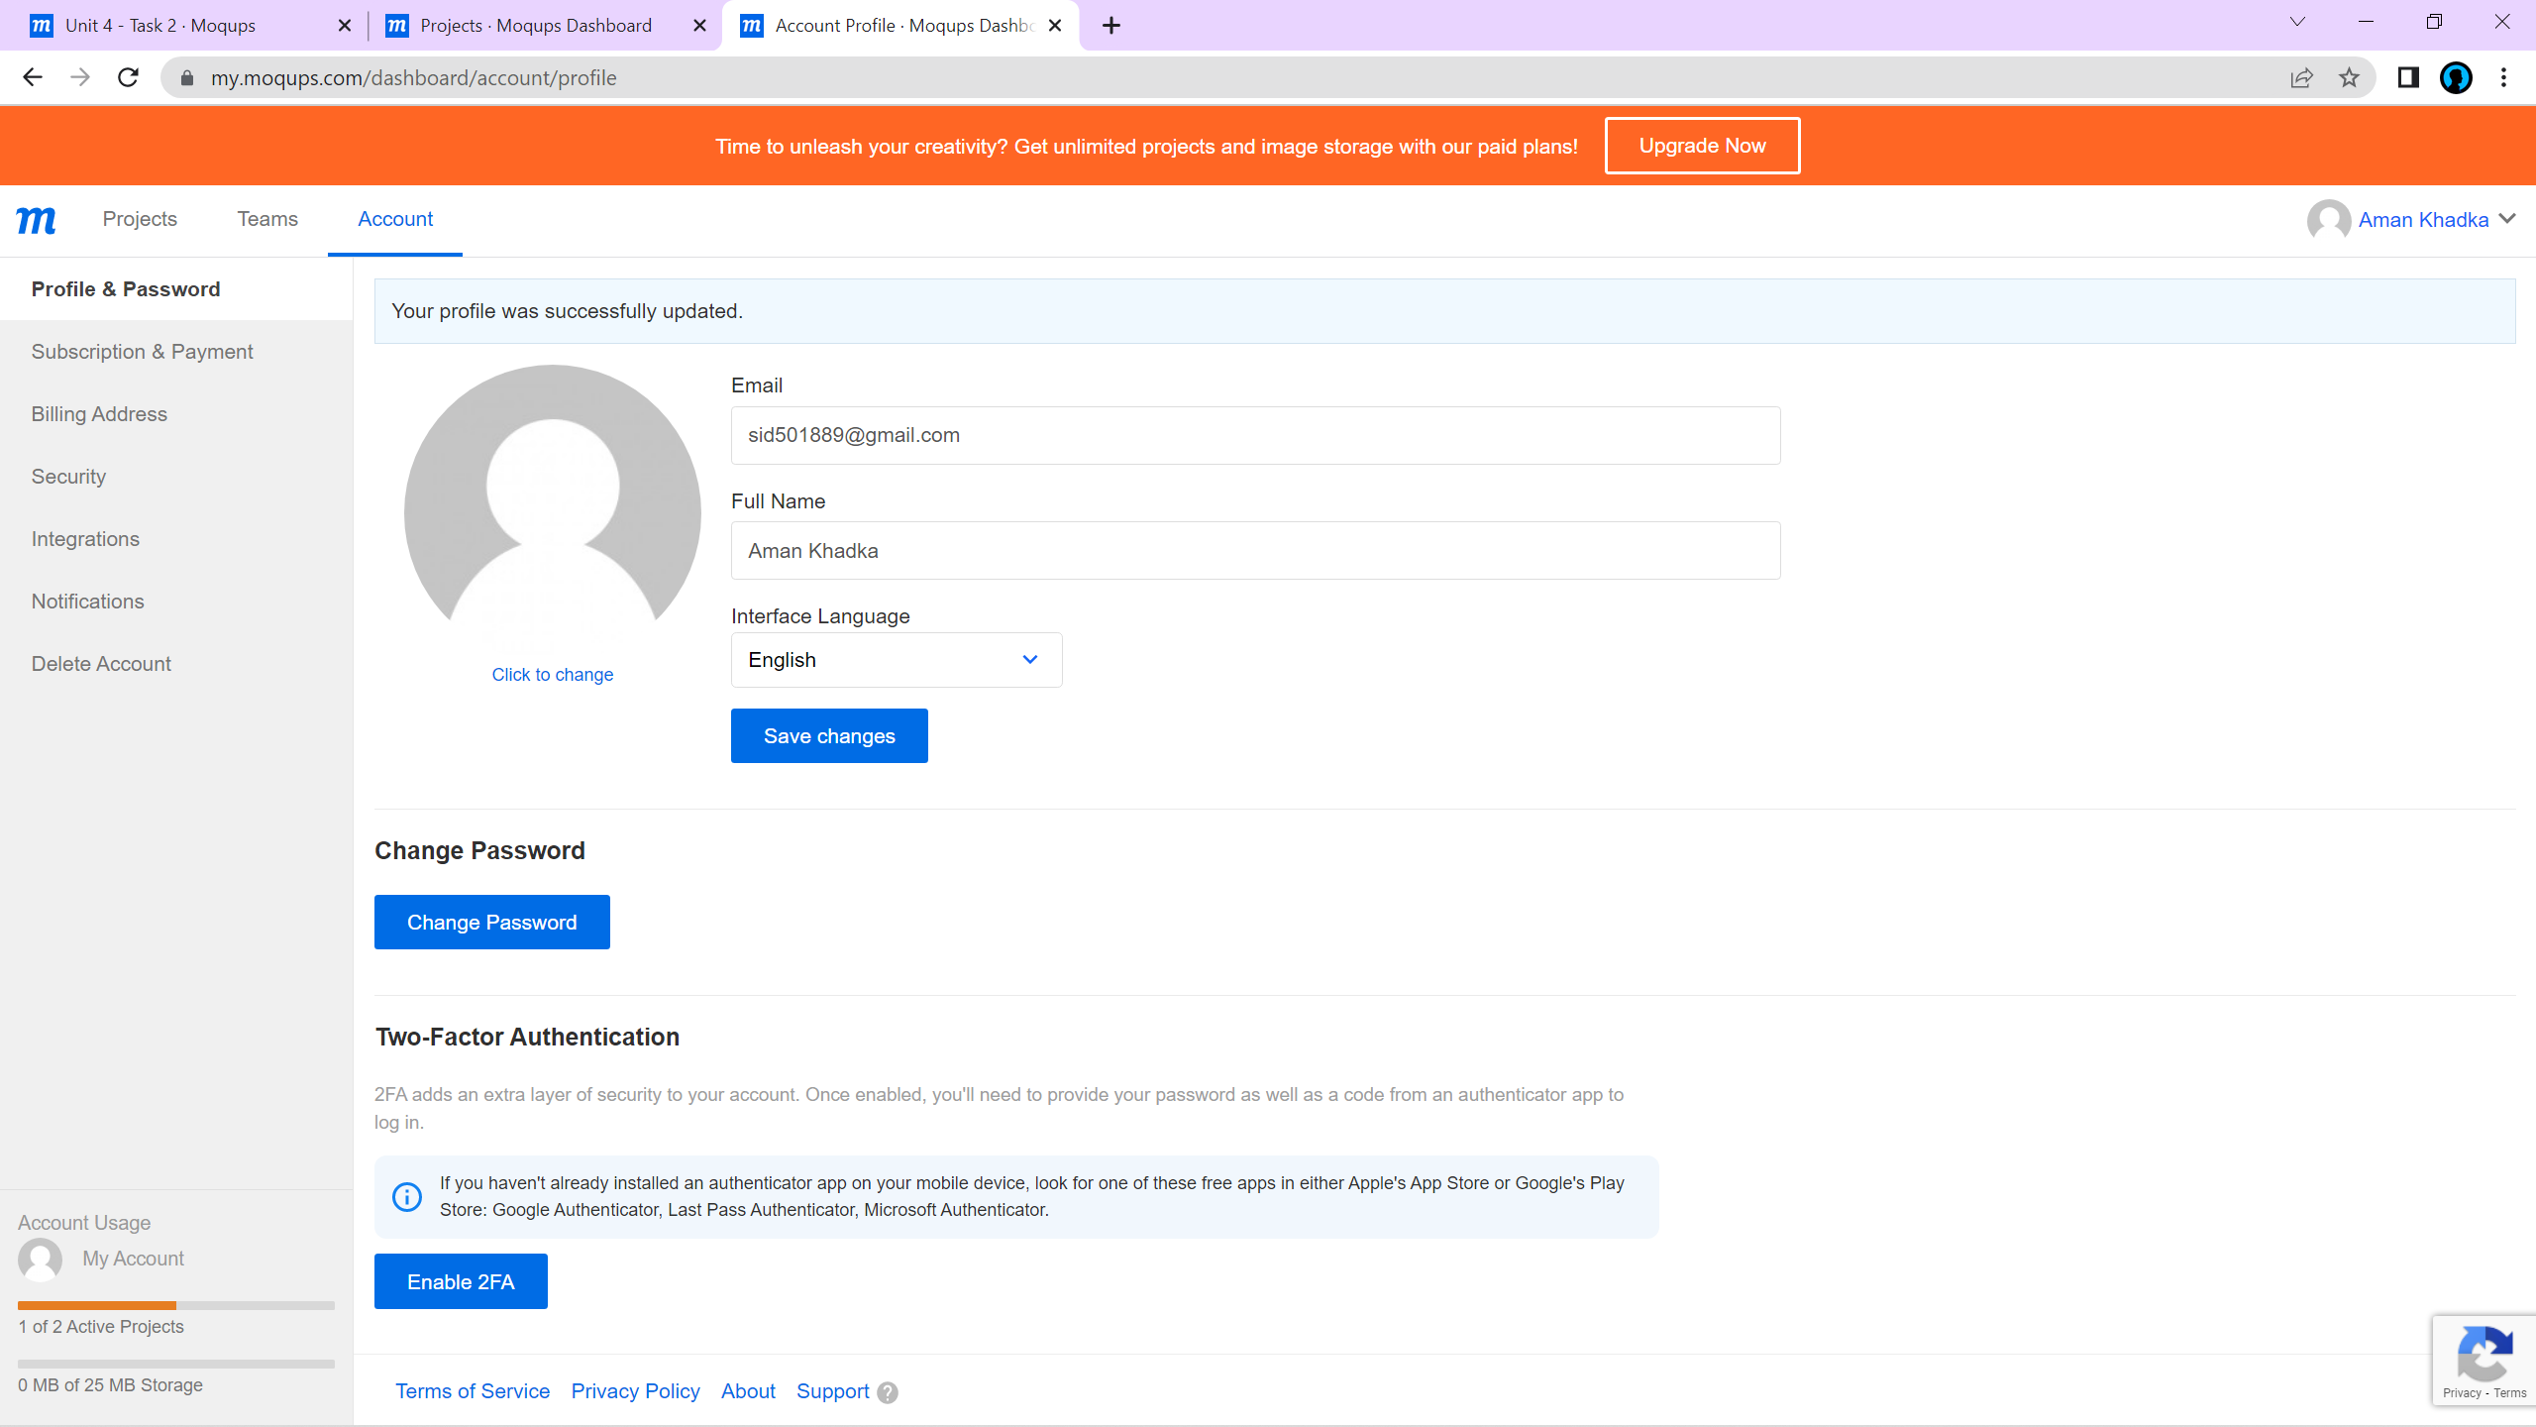

**Task 2 and Task 3**

Moqups Link = <https://app.moqups.com/WcBay1WDJOzGoFWrZBcxUYH2hbp9VKll/view/page/ae23e6674>

